Zoom Video Conferencing Instructions

Overview: What is Zoom Video Conferencing
Zoom is a cloud-based platform for video and audio conferencing, mobile collaboration, and simple online meetings. Zoom's web-based conferencing uses high-quality video and audio and is accessible on Macs, PCs, and mobile devices. A webcam is desirable but not required.

Installing the Zoom app (desktop or mobile)
Using Zoom with a Windows, MacOS or mobile device requires the installation of an app. When you are invited to participate in your first Zoom meeting via an URL link, Zoom will prompt you to download the app when you click on the URL link. You do not need to pre-install the app. Please start this process 15 minutes before the event start time.

Zoom users can also install the app in advance by going to https://zoom.us/download. An app is also available for iOS from the Apple App Store and for Android from Google Play. At either location, search for "zoom".

Joining a Scheduled Meeting
You will be emailed an invitation to join a Zoom meeting. See the example below:

Click on the URL link to join from PC, Mac, iOS or Android. (Black arrow). If asked for the meeting ID, copy and paste the meeting ID at the bottom of the message. (Red arrow). If you have not yet joined a Zoom meeting, you will be asked to download the app at this time.

Testing Your Computer Audio/Video
- When you join a Zoom meeting you will be prompted with the window shown below. Select the Test Computer Mic and Speakers option.
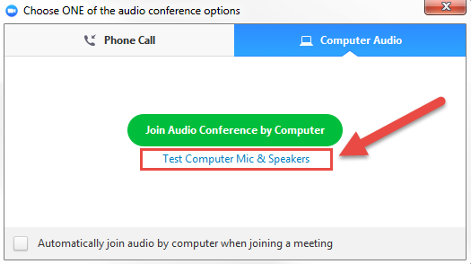
- Test your sound by clicking on the Test Speaker button and watching the volume bar move. Select the speaker dropdown and try a difference speaker source if you can't hear the other side. Don’t worry about testing your microphone – that functionality won’t be necessary for this event. Close the window to return to the main screen.
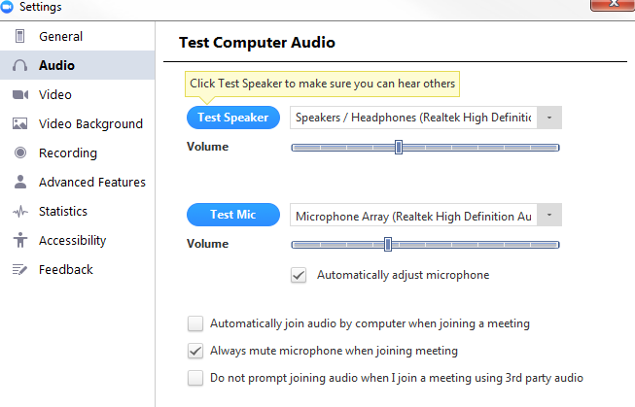
- After testing your audio select the Join Audio Conference by Computer button (Helpful Hint: If you don’t see this option select the Join Audio button in the lower left corner of your screen).
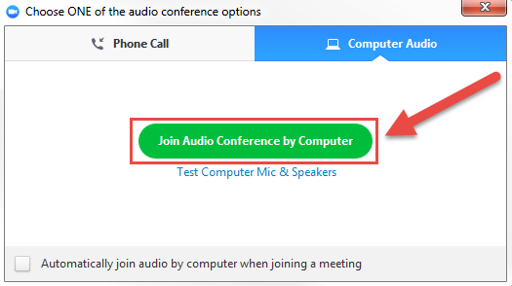
- The Zoom controls are shown below including options for: mute, share video camera, participant list, chat and how to leave a meeting.
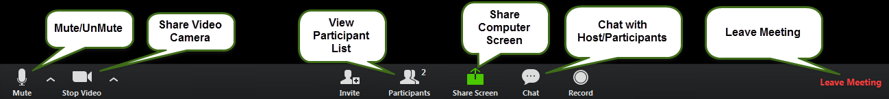

Muting Your Sound
During a meeting it is easy to mute your microphone when you aren’t speaking by clicking on the microphone icon in the bottom left side of your screen (shown in screen shot above).

Using a Phone Number Instead of Computer Audio
If you have any problems with your audio or if you need to join a meeting while you aren’t by a computer, call the phone number listed in the meeting invitation. You will need to enter the meeting ID number.

